**Visualizing Time series- Report**

Multi Line charts or Multi Line graphs are known for representing the relation between two or more dynamic or distinct data sets. A multiple line graph shows the relationship between independent and dependent values of multiple sets of data. Usually multiple line graphs are used to show trends over time. In a multiple line graph, there are two or more lines in the graph connecting two or more sets of data points. The independent variable is listed along the horizontal, or *x*, axis and the quantity or value of the data is listed along the vertical, or *y*, axis. They are designed to show an interaction for two discrete and one continuous variable. To show no interaction for two discrete and one continuous variable. It can also be used to explore for a trend with two discrete and one continuous variable. Multiple line graphs have space-saving characteristics over a comparable grouped bar graph. Because the data values are marked by small marks (points) and not bars, they do not have to be offset from each other (only when data values are very dense does this become a problem). Another advantage is that the lines can easily dual coded. With the lines, they can both be color coded (for computer and color print display) or shape coded with symbols (for black & white reproduction).

**Visualizing Map that is integrated with the Graph**

When visualizing a graph with multiple states, it is quite important to acknowledge the necessity of the presence of map along with the graph so as to make the selection and visualization of the data much simpler and easier for an end user.

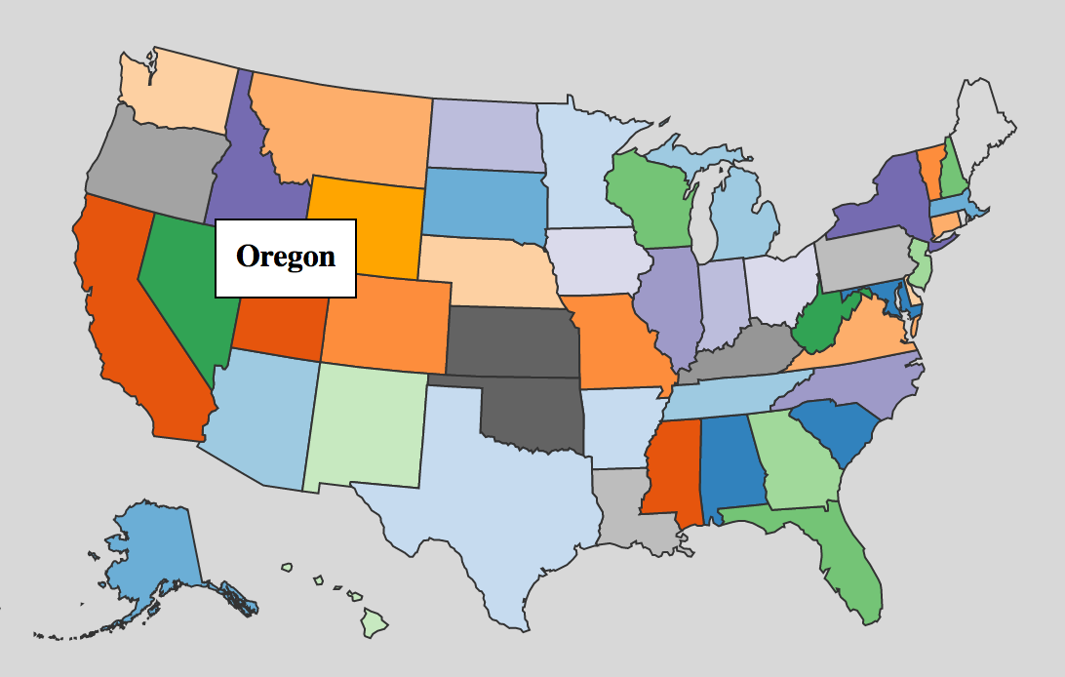

The map is well equipped with functions like tool-tips that pop up the name of the state when hovered over. It also has function, that when clicked on, result in producing a line graph in the graph adjacent to the map.

**Sudden Pump and Sudden Drop**

The web page is equipped with sudden drop and sudden pump functions that allow the user to identify rare evets where the unemployment rate takes a sudden toll or quick rise in a short period of time. This , thereby , represents the amount of development and of sudden cut in the employment time series.

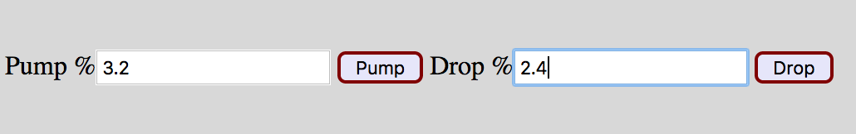

In the above example, the functions notify of a time series of a state over the span of almost 40 years, where there is sudden drop of 2.4% as well as 3.2% rise in the unemployment rate, irrespective of the time they both occurred.

**Reset Button and Selecting all States**

Instead of selecting all the 50 states together to visualize the line graph according to the give data set. The checkbox also allows the user to deselect all the selected states. The check-box used for this function is ‘Select all States’. When the user selects two or more time series in the graph, the button ‘Reset Graph’ allows the user to acquire a clean and empty graph with no time series selected.

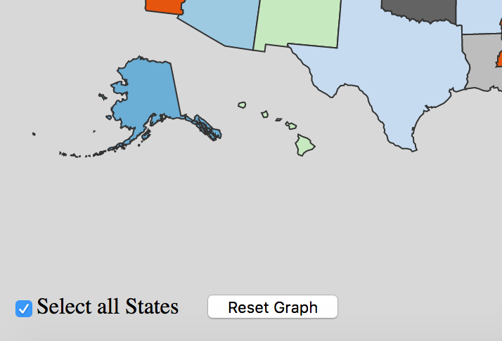

**Visualizing and plotting the time series in the Graph**

Visualizing time series in a graph is achieved when either the states in the map are clicked on or the ‘Select all the States’ button is clicked. Every time series graph is visualized dynamically and is very user friendly. The interaction between the user and the web page is likely to be much simpler.

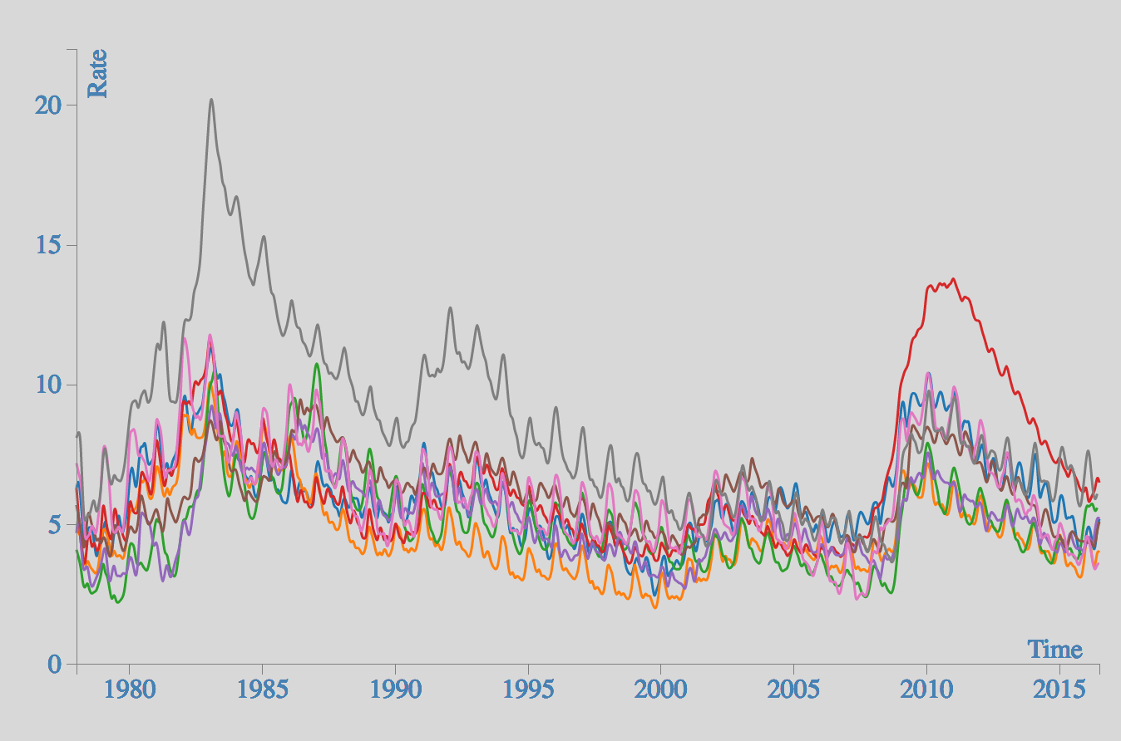

The above example shows that the graph bears the unemployment rate on the Y-Axis and the time period on X-Axis. The above Graph plots time series of 8 or more number of states. Multiple inputs for this graph come from the map feature of the web page where multiple states can be clicked on to compare the unemployment rate between all the states selected.

**Acknowledgement**

This project work is a part of the project-1 that is assigned to all the students of Visualization and Visual Analytics of the year 2016.